Lab Assignment 2: Practicing DDL and DML command
Introduction to Databases (CSE 3151)
Programme: B.Tech. (CSE & CSIT) Semester: 6th

Objective: To understand and apply DDL and DML commands for modifying database structure and manipulating data in a Banking database.
1. Write the SQL expressions for the following SQL queries and verify it in your PC by executing it.
a) Display the structure of all the tables created in Assignment (1).
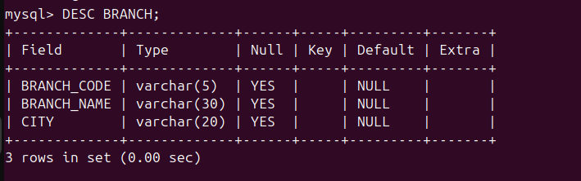
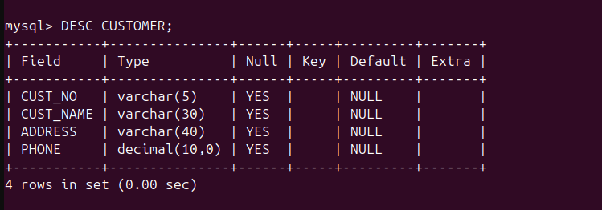
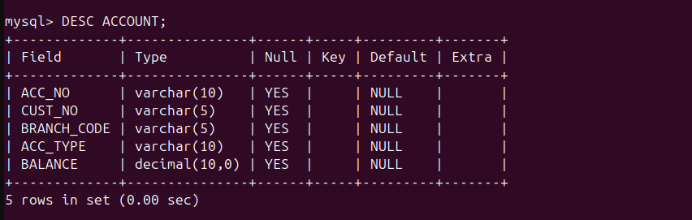
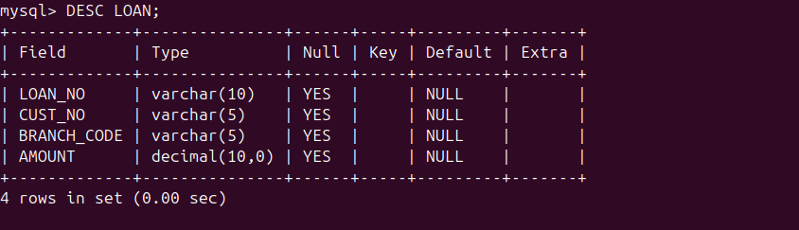
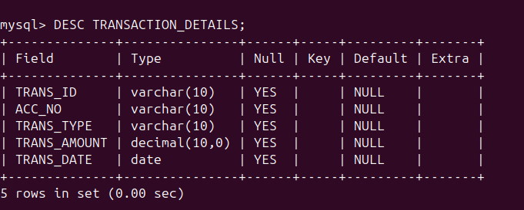
b) Display the contents of all the tables created in Assignment (1).
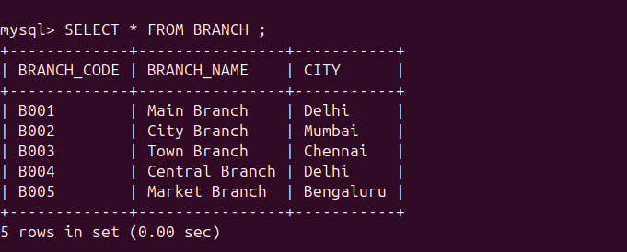
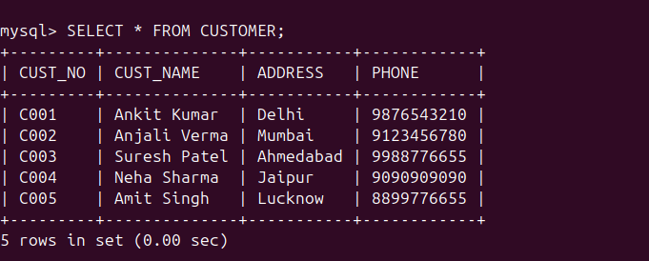
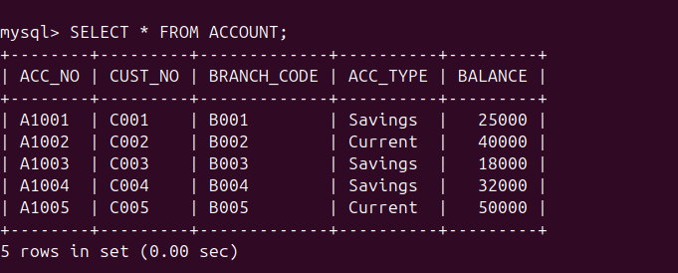
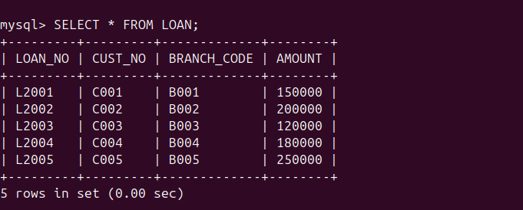
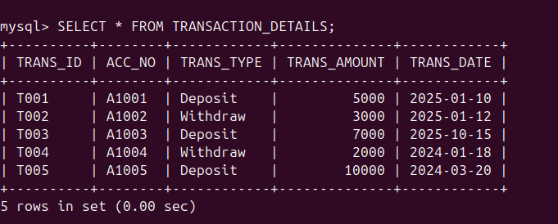
c) Display the customer number and branch code of each account holder.
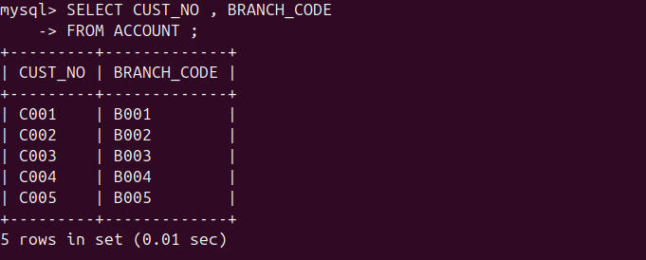
d) Display the customer number and account balance of customers having Savings accounts.
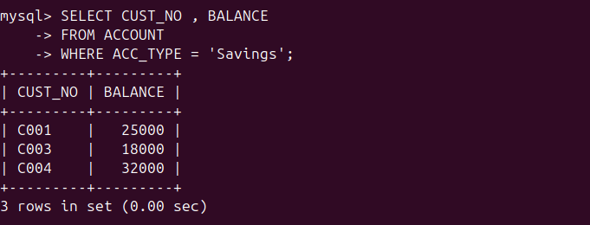
e) Display the account number and transaction ID of customers who have made deposit transactions with a transaction amount greater than 5000.
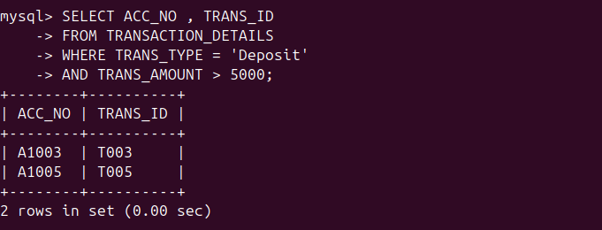
f) Display the records of customers whose loan amount is less than 200000.
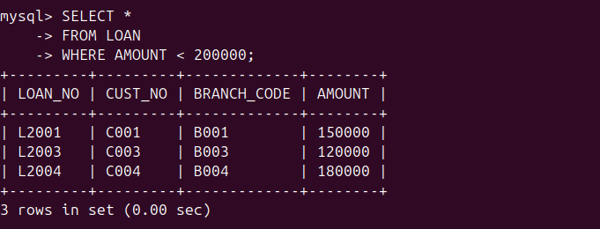
g) Display the customer numbers of customers who do not have Savings accounts.
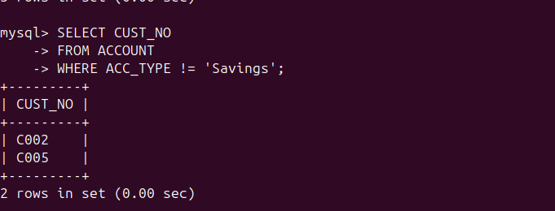
h) Display the names of different cities distinctly available in the branch table.
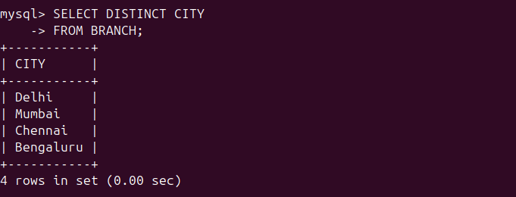
i) Display all account numbers that have transactions in the month of January 2025.
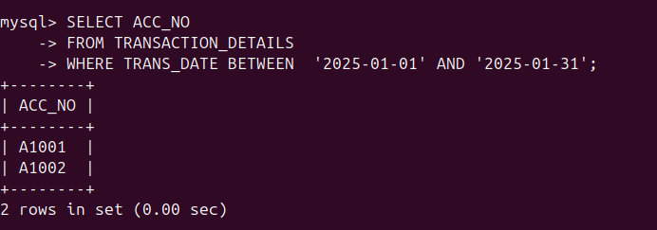
j) Display account numbers whose balance is not equal to 32000.
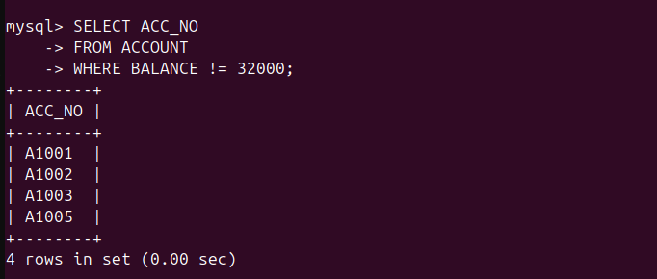
k) Display all columns of the account table sorted in descending order of account balance.
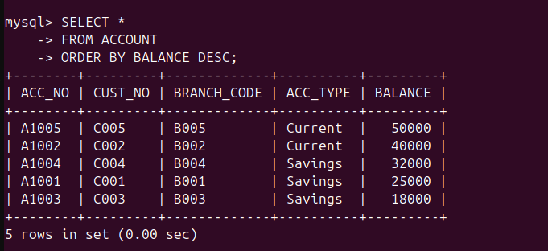
l) Add a new column EMAIL to the customer table.
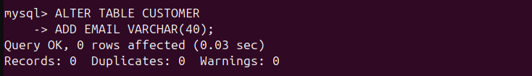
m) Insert email values into the existing rows of the customer table.
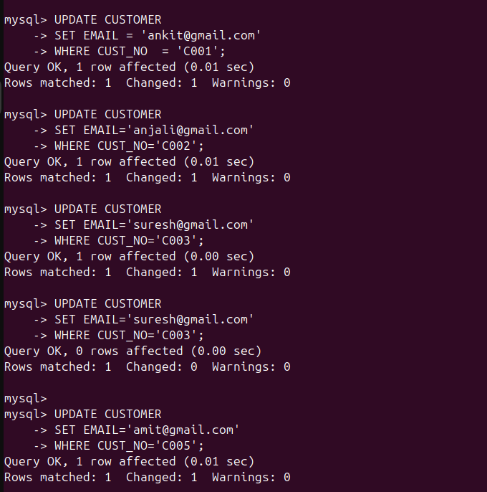
n) Change the column name CITY to LOCATION in the branch table.
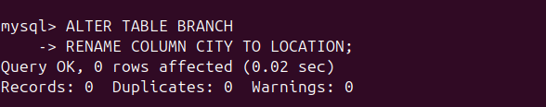
o) Change the name of the table TRANSACTION_DETAILS to BANK_TRANSACTION.

p) Change the column name ACC_NO to ACCOUNT_NO in the account table.

q) Change the data type of CUST_NAME column to VARCHAR (50) in the customer table.
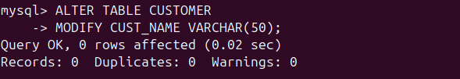
r) Change the name of the ACCOUNT table to CUSTOMER_ACCOUNT.

s) Change the column size of BRANCH_NAME in the branch table from 30 to 40.
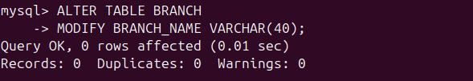
t) Delete all the contents of the BANK_TRANSACTION table.


